**Vancouver Island West School District #84**

Criminal Record Checks - VOLUNTEERS

Please **Use online** request at <https://justice.gov.bc.ca/criminalrecordcheck>

Anyone doing a check will need the access code :**7JSVY29LVU**

Reminder this site is only for volunteers of School District #84.

Instructions:

**Step one:**  Enter the Access Code

**

**Next page, enter “Volunteer” in the job title**

Make your selection on how to proceed by clicking your option on the document, which will take you to the next step

**Continue without BC Service Card**

Step 3: Fill out your information, then click next on each page to continue ……….

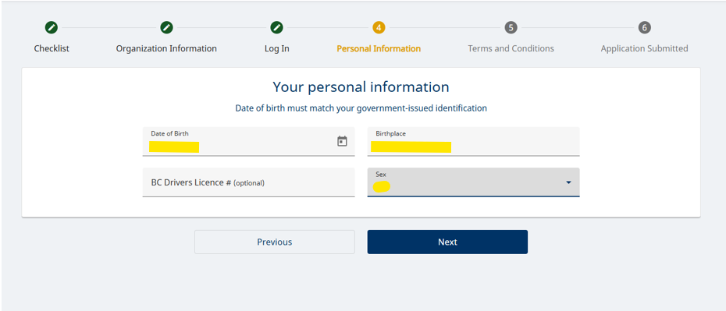

Please use only your mailing address. PO boxes are accepted; use the Canada Post search

Review your information is correct. If something is wrong, click the edit pencil

**Step 4:** Read through and check off that you agree to all terms.

**Step 5:** Your application is now complete. Please stop into the school you are volunteering at and show them a piece of valid government-issued ID and let them know you have filled out the criminal record online application.

**With BC Services Card**

Step 3: Fill out your information, then click next on each page to continue ……….

Please use only your mailing address. PO boxes are accepted; use the Canada Post search

Review your information is correct. If something is wrong, click the edit pencil

**Step 4:** Read through and check off that you agree to all terms.

**Step 5:** Your application is now complete.

